Curriculum vita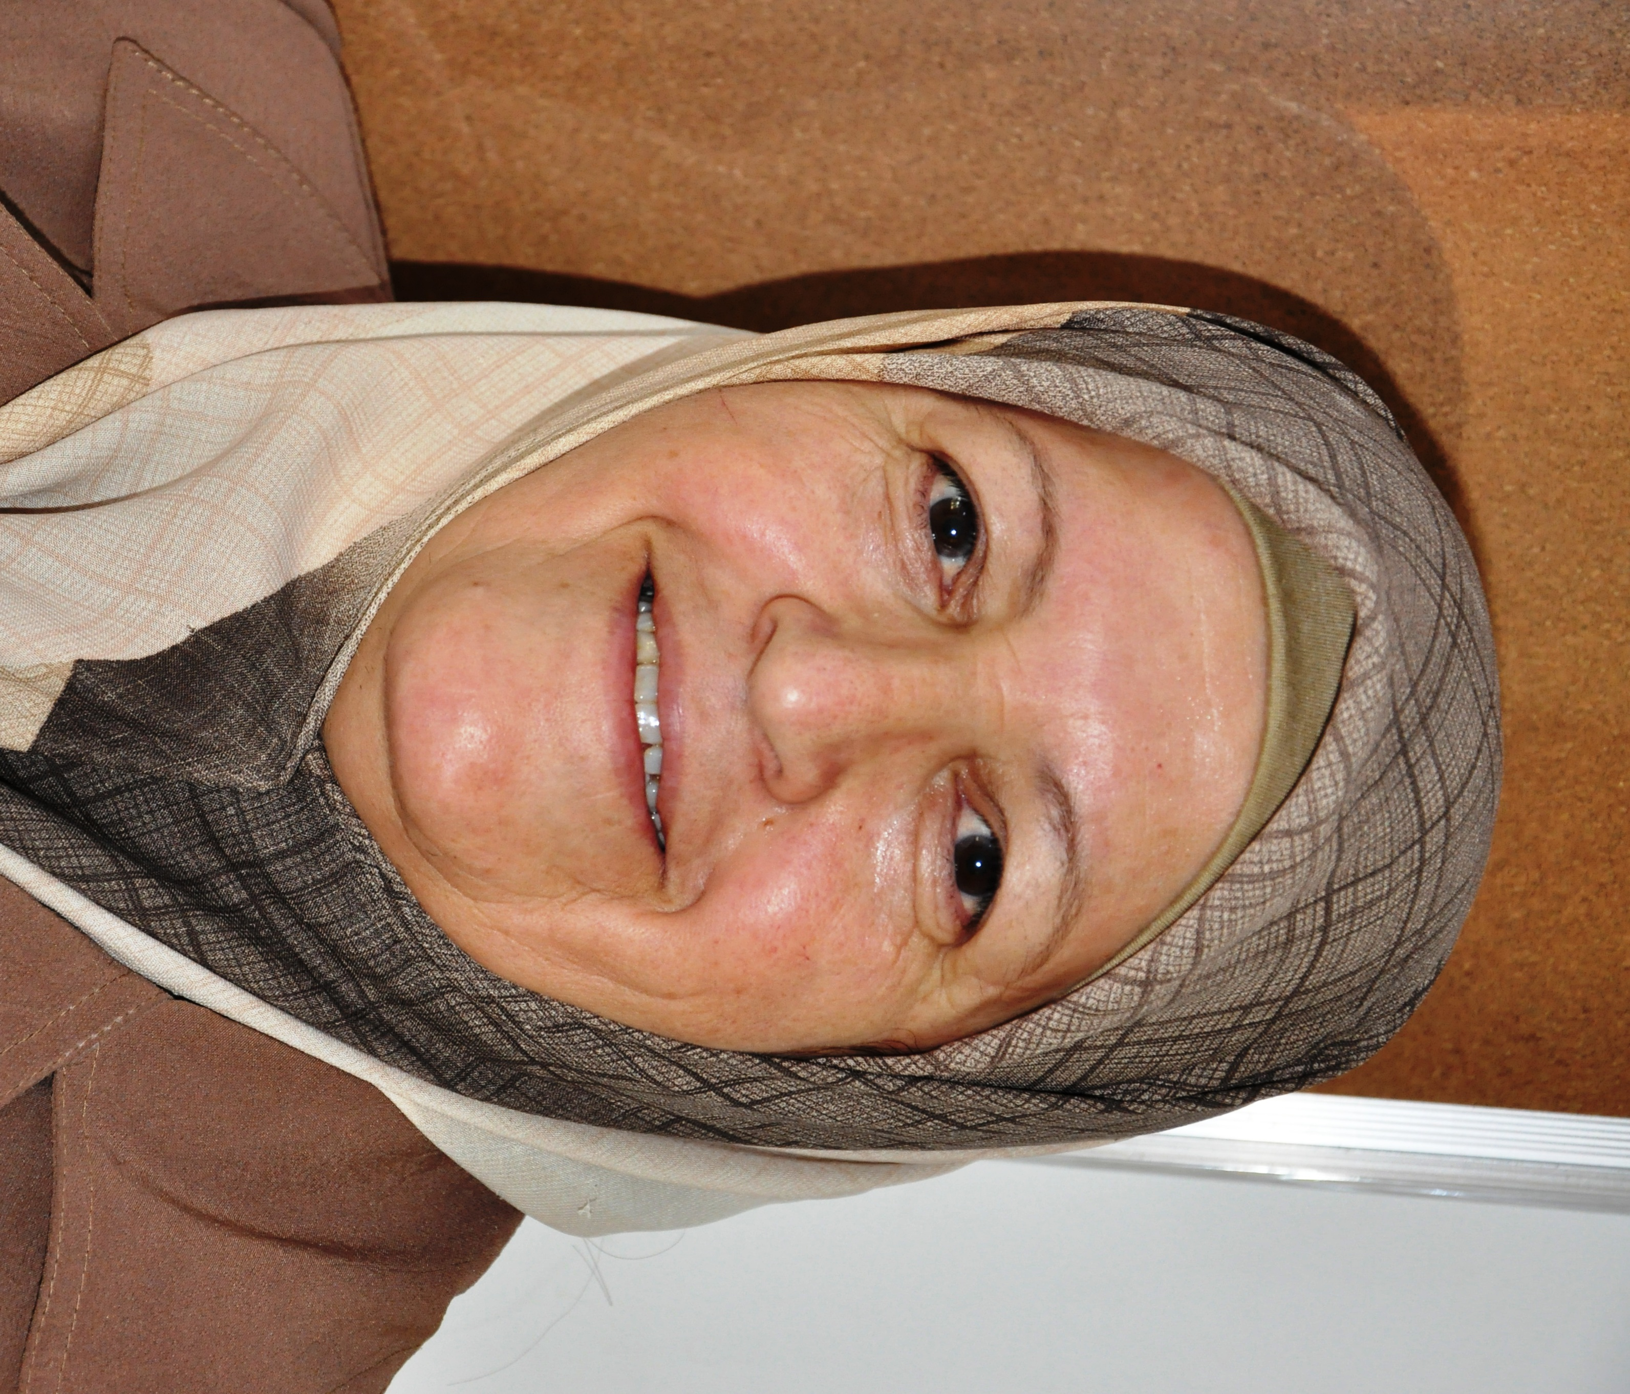
Personal information:
Name : Sana Thanoon Ahmed Al-Othman
Date of Birth :25\12\1955
Place of Birth :Mosul –Iraq
Nationality : Iraqi
Assistant professor in adult nursing
Qualification:
University | Year of Award | specialty | Dgree
Mosul | 2000 | nursing Science\oncology | MSc
Baghdad | 1978 | Science Nursing`` | BSc

The title of master thesis was" Nursing Assessment of Quality of life and Satisfaction of Care for Patient with Stoma( colon cancer) ."
Professional Experience
Period of Work | Subject | Place | Position
2003-2008 | Administration | Department of Nursing \University of Mosul | Ag. Head of  Nursing Department
1994- to present | Medical Surgical Nursing\Fundamental of Nursing \Ethics | Department of Nursing\University of Mosul | Lecturer
1978 -1983 | Cardiology | Taamem Hospital | Head Nurse in CCU
1983-1994 | Most subjects | School of Nursing | Nurse

2010-2018 | Adult nursing | School of nursing | Head of department
Other Experience
Period | Subject | Place | Type of Experience
2012,2013 | Nursing skill & practice | Turkey | Summer training
7\8-17\8\2010 | Nursing skill & practice | Iran | Summer training
3\4-14\4\2006 | Nursing education& practice | Bahrain | Orientation visit
3\6-3\8--2004 | 2 Months training \nursing research | USA | Jackson heart training program
1994-2008 | Council ling of patient with cancer | Nuclear hospital | Volunteer nurse in pain clinic\support group
1996-to present | First Aid | Iraqi Red Crescent | First aids trainer
5\6—4\8\1977 | Nursing skill & practice | Uk | Summer training
3\12\1983-1994 | Manager &teacher | Mosul | Head of school nurses\primary
2008 -2018 | Nursing education& practice | Nursing college\Duhok | Lecturer & head of nursing department
Publications
Title | Year
POST CEREBROVASCULAR ACCIDENT PATIENTS' QUALITY OF LIFE ATTENDS TO DUHOK SPECIALIZED CENTER OF RHEUMATIC DISEASES AND MEDICAL REHABILITATION.  SARA J. KADHIM¹, SANA T. AHMED ²  1 BSc. In Nursing Science, College Of Nursing, University Of Duhok.  2 Assistant Professor, Adult Nursing, College Of Nursing, University Of Duhok  Acceptant Znko Duhok journal \12\9\2019 | 2019
Assessment of Nurses’ Knowledge towards Management of Patients with Burn  Miaad Hussein Kadhim: Lecturer, Adult Nursing Department, College of Nursing, University of Duhok-Iraq.  Sana Thanoon Ahmad: Assistant Prof., Adult Nursing Department, College of Nursing, University of Duhok-Iraq  Saadia Kadhim: Nurse Practitioner, Duhok General Directorate of Health, Duhok-Iraq  Corresponding author” Email: sana.ahmed@uod.ac Tel: 07503158806  Acceptant Znko Duhok journal 24\9\2019 | 2019
Role of nurses in health needs of refugees and Internally Displaced Peoples  22 Erbil j. nurs. midwifery, Vol. 2, No. (1), May, 2019  Original Article | 2019
 | 2019
Assessment of knowledge and practice of mothers about diarrhea among children under 5 years in Duhok city.  Sana Thanoon\assist.prof. | 2012
Proposal Program for Upgrading Continuous Nursing Education and Nursing Services for Duhok Governorate – Iraq  Sardar Eisa Sana Thanoon | 2011
Assessing nursing role for preparation of patient for cardiac catheterization in Mosul | 2010
Designing web page for post operative care | 2008`
Assessing the risk factor for patient with pneumonia in Ibn –Sina hospital in Mosul. | 2008
Ahmed ,Sana:2005 Nursing assessment for patient with angina pectrior | 2005
Abdullah , Ahmed and al-Othman , Sana:2004 Knowledge and attitude of mother about vaccination of children . | 2005
Abdul-Razzak , Bayda and al- Othman , Sana :Assessment of Nutritional status of primary school student in Mosul city . | 2004
Abdlluah , Ahmed and al- Othman ,Sana :2004 Mother attitude toward their children with ARI and their relation with some variable . | 2004
Abdullah , Ahmed and al-Othman ,Sana :2003 The effect of educational program on the knowledge and practice of female student about breast self examination | 2003
Al-Ramadani , Ayad .Al-Othman , Sana :2000 Guideline on pain relief and palliative care for cancer patient . WHO | 2000

Languages:
1-Arabic
2-English
3-kurdish
E-Mail: sana.ahmed@uod.ac, ,

