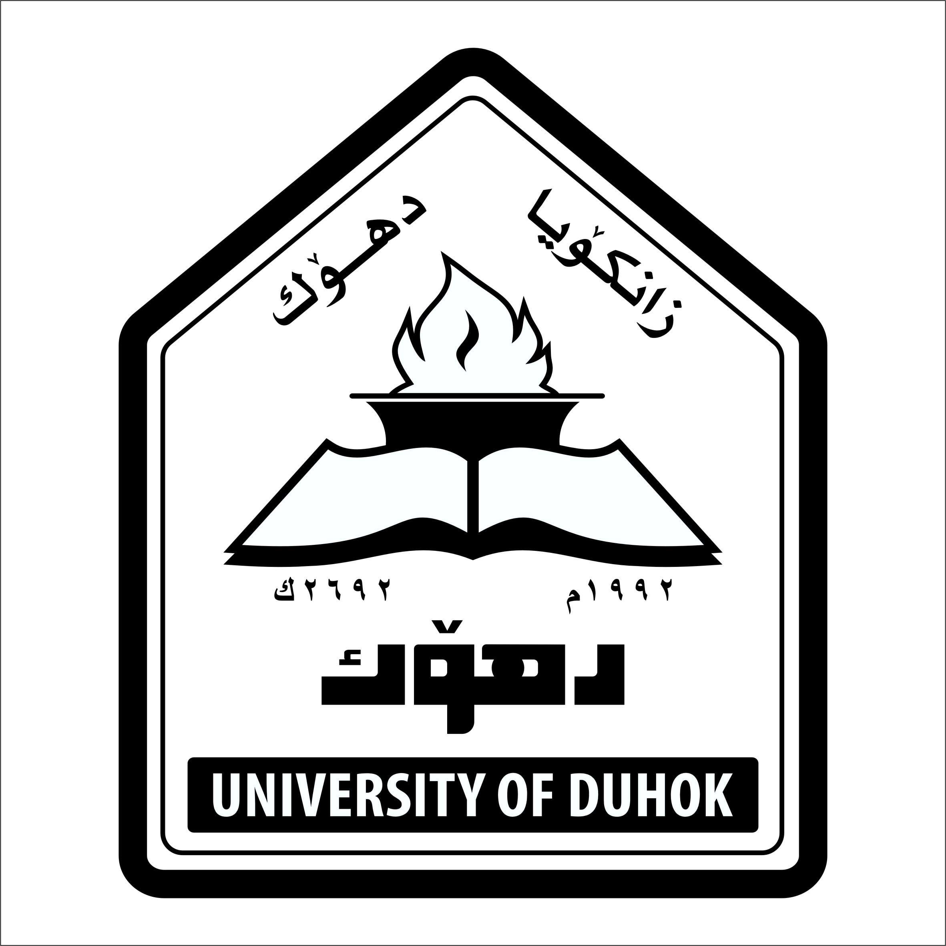

CURRICULUM VITAE

Name: Hoger Mustafa Najman
Date of Birth : 5/8/1972 Duhok
Material Status ; Married with five children
Wife :1- Nazdar Ahmed Najman
2- Naamatulla Ahmed Muhamed
Nationality: Iraqi
Languages: Kurdish , Arabic , English
Telephone / Mobile : 009647504571746
E mail : hoger.mustafa.@uod.ac
QUALIFICATIONS
- B.D.S Mosul University, Iraq, 1995
- H.D. in Conservative dentistry ,University of Sulaimany 2005
- M.Sc. in Pediatric Dentistry, Hawler Medical University,2008

MEMBERSHIPS
- Members in Iraqi Dental Association since 1995
- Members in Kurdistan Dental Association since1996

SCIENTIFIC COURSES & DENTAL CONFERENCES
- Participation in most annual dental conferences of Iraqi dental association & college of dentistry in Iraq.
- Participation in training course of dental implantation in B&B system, duhok, 2008
- Participation in UAE international Dental Conference & Arab Dental Exhibition , AEEDC Dubai , 2009.
- Certification in methods of teaching for higher education 2009.

- Participation in the Cairo dental Conferences ( Egypt ), 2010.
- Participation in IAPD 2011(International Association of Pediatric Dentistry) in Athin-Greece 2011.
- Participation in UAE international Dental Conference & Arab Dental Exhibition , AEEDC Dubai , 2012.
- Participation in training course of implantology ,Duhok University, School of Dentistry, 2013.
- Participation in the first Scientific Meeting of Dentistry ,Duhok Polytechnic University ,2014.
- Participation in UAE international Dental Conference & Arab Dental Exhibition , AEEDC Dubai , 2016.

EMPLOYMENT HISTORY
1995-1996 Duhok Specialized Dental Health Center (rotational training)
1996-2000 Duhok – Zaxo City-general hospital –Sumel hospital (graduational training)
2000-2002 Duhok – Duhok Health Center (GDP- xabat Health Center)
2002-2004 Duhok city Barzan Dental Health Center (GDP)
2005-2006 High Diploma student in conservative dentistry -college of dentistry . Sulaimany University.
2006- 2007 M.Sc student, Hawler Medical University.
2008-2009 Specialist in Pedodontics in Duhok Specialized Dental Health Center.
2009- 2013 Assistant Lecturer in Dental anatomy ,Dental Material in School of Dentistry /Faculty of Medical Sciences- Duhok University .
2009-2011 Head of Department of Restorative Rentistry ,School of Dentistry, Faculty of Medical Sciences ,Duhok University.
2012- to date Assistant Lecturer in Pedodontics in Department of P.O.P,School of Dentistry, Faculty of Medical Sciences ,Duhok University
2011-2013 Head of Department of P.O.P,School of Dentistry, Faculty of Medical Sciences ,Duhok University.
1997 – to date Private clinic in Duhok City.
2016 february Ph .D. student, college of dentistry-Hawler Medical University

Thiesis and Publications:
Assesment of microleakage of different restorative materials in pulpectomised primary molars invitro study.

