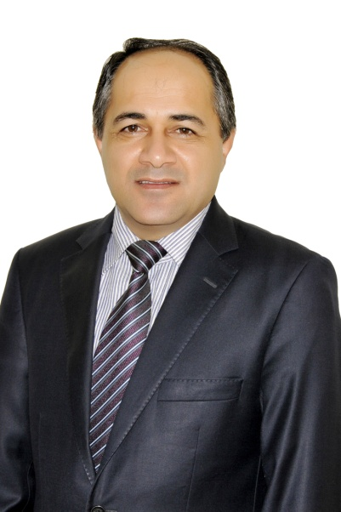
(Assistant Professor), Molecular microbiology & Immunology
College of Medicine, University of Duhok, Duhok
Duhok, Kurdistan Region, Iraq
Phone No.: 00964 750 4695391
e-mail: dr.ahmed@uod.ac

Current Position:
Head, Medical Research Center, College of Medicine
University of Duhok (2015- till present)
Previous Positions:
- Dean, Faculty of Science, Duhok University, Dec. 2010 – Sept. 2015
- Dean, College of nursing, Duhok University, Sept. 2008 - Dec. 2010
- Vice Dean, College of Medicine, Duhok University, May 2007 - Sept. 2008
- Head, Scientific & post graduate office, College of Medicine, Duhok University, Sept. 2006 - May 2007
- Head, Microbiology department, College of Medicine, Duhok University, Jan. 2007 - May 2007
- Vice Dean, college of medicine, College of Medicine, Duhok University, Sept. 1998 - Aug. 2002
- Head, registration office, College of Medicine, Duhok University, May 1997 - Sept. 1998
Education
- Ph.D., Molecular Microbiology, University of Nottingham, UK, in collaboration with university of Duhok, 2006.
- M.Sc., Molecular Medical Microbiology, The university of Nottingham, UK, 2005.
- M.Sc., Immunology, University of Salahaddin-Erbil, 1996.
- B.Sc., Biology, University of Mosul, 1986.

Academic Experience:
- As an assistant professor in the field on molecular microbiology and immunology, I committed to teaching duties in both undergraduate and postgraduate students, also I am spending much of my time in the research field through supervising the M.Sc. and Ph.D. students and also sharing other researchers in the university to conduct researches.
- For the last 15 years, I have been involved in teaching the (Medical immunology) for the third year medical students, as getting my first M.Sc. in immunology. Once I earned my second M.Sc. degree and Ph.D. degree in the field of (Molecular Medical Microbiology ) with the collaboration of Nottingham university, UK, I have started since 2006 to teach the Molecular Microbiology and Immunology for postgraduate students (both Ph.D. and M.Sc.) in medical college and science students at the university of Duhok. All my researches are conducted in the field of (Molecular Microbiology and immunology).
- The other part of my working time is usually spent for research management. As a chief, medical research center, I need to collaborate with other departments at the college including the research, to draw and prioritize research projects to fulfill the scientific plan at the college.

Workshops and other Certificates:
- Professional Development Workshop, Bridgewater State University, Boston, USA, 2013.
- Collaboration workshop between Michigan State University and University of Duhok on Higher Education, Michigan State University Michigan, USA, 2013.
- Best practices in publishing research, UoD, 2012
- University staff development, UoD, 2012
- Scientific conference of the faculty of medical sciences, UoD, 2012.
- Staff Development training for medium level leaders of universities (University of Kassel, Germany), 2012.
- Infection control in hospitals, Shahid Beheshti Hospital, Tehran, Iran, 2009.
- Molecular techniques in the diagnosis of trans-boundary diseases, Razi Research Center,
- Tehran, Iran, 2008
- Molecular Techniques in Disease Diagnosis, Pendik Research Center, Istanbul, Turkey, 2008
- Molecular Techniques, UoD, 2007
- ELISA Technique (FAO, UN), UoD, 2001

Ph.D. / M.Sc. Program Supervision:
- Assessment of hospital acquired infections due to MRSA in Duhok city, 2007. M.Sc.
- Sensitization of human cord blood lymphocytes against CEA under heat shock conditions, 2008, M.Sc.
- HLA typing using SSP-PCR in comparison with the serological methods in Duhok City, 2008, M.Sc.
- Using nested PCR in detecting Rifampicin resistant TB, 2011, M.Sc.
- Clinical and epidemiological characterization of Mycobacterium TB isolated from Duhok province, 2012. Ph.D.
- Detection of BRAF mutation among thyroid cancer patients in Duhok, 2013, M.Sc.
- Genotyping of Echinococcus granulosis isolated from human and some domestic animals using RFLP, 2013, Ph.D.
- The role of PCT in Streptcoccus pneumonia infections, 2014, M.Sc.
- The role of PCT in Salmonella typhi infections, 2014, M.Sc.
- The level of IL-1 & IL-8 secreted in Saliva in Bahjet disease patients, 2014, M.Sc.
- Detection of H-pylori in aphthus stomatis patients using PCR, 2015, M.Sc.
- Anti- cellular compartment antibody level in Behcets disease patients, 2015, M.Sc.

Publications:
- HSP60 Induces carcino embryonic antigen sensitization and cytotoxic activity of human cord blood T lymphocytes on HELA cancer cells, Duhok Medical Journal

- Determination of dyspepsia causes in patients attending endoscopy department of Azady teaching hospital in Duhok city, Zanco medical Journal

- Risk factors for multi-drug resistant tuberculosis: a review, Duhok Medical Journal
- First insight into the genetic diversity of Mycobacterium tuberculosis strains from patients in Duhok, Iraq, Chemotherapy, (56), 2010.

- First insight into the drug resistance pattern of Mycobacterium tuberculosis in Dohuk, Iraq: Using spoligotyping and MIRU-VNTR to characterize multidrug resistant strains, Journal of Infection and Public Health, (4), 2011.

- The Most Predominant Spoligopatterns of Mycobacterium tuberculosis Isolates among Iranian, Afghan-Immigrant, Pakistani and Turkish Tuberculosis Patients: A Comparative Analysis, International journal of Mycobacteriology, (1), 2012.

- Ophthalmia neonatorum in Duhok, North of Iraq, bacteria causative agents and their antibiotic sensitivity pattern, ISRA medical jornal, (4), 2012.

- Human Leukocyte Antigen (HLA) typing by polymerase chain reaction-sequence specific primers (PCR-SSP) in comparison with serological methods, Duhok Medical Journal, (6), 2012.

Molecular determination of Echinococcus granulosus isolated from human hydatid cyst using mitochondrial nad1 gene sequencing in Duhok Province- Kurdistan Region, Iraq, The first scientific international Conference of Zakho University, 2013.

- Molecular Characterization of Echinococcus granulosus isolated from human hydatid cyst using mitochondrial cox1 gene sequencing in Dohuk Province- Kurdistan Region, Iraq, The Journal of University of Zakho, (1), 2013.

