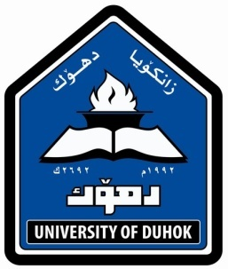
CURRICULUM VITAE
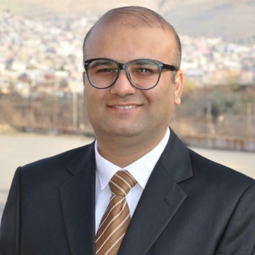
PERSONAL HISTORY:
Name : Mohammed Rashed Nabi Aldoski
Place Date of Birth: Duhok, January 14th 1984
Current position : Acting Vice Dean of Dentistry College /Duhok University
Marital Status: Married
Nationality: Iraqi
Languages: Kurdish, English and Arabic
Telephone / Mobile: 009647504580761
E- mail: mohammed.bandi@uod.ac
sherko.dentist@gmail.com
Address :Duhok,Azadi, Spede street.

QUALIFICATIONS:
Degree | Degree Major | Institution and location | Date Conferred
B.D.S | Dentistry | Hawler medical University/Iraq | 2010
M.Sc. | Conservative Dentistry | Hawler medical University/Iraq | 2015
MASTER  THESIS TITLE | EVAULATION OF ENAMEL MICROHANDNESS AND SHEAR BOND STRENGTH OF COMPOSITE RESIN TO ENAMEL POST DIFFERENT TREATMENTS | college of dentistry  Hawler medical University/Iraq | 2015

ACADEMIC AND PROFESSIONAL RESPOSIBILITIES :
2015-date Acting vice Dean of College of Dentistry
2010- 2015 joiner dentist at of School of Dentistry, Faculty of Medical Scienc Duhok University.
2010 to 2012 joiner dentist at Conservative Department, School of Dentistry.
2012- 2015 Msc student, College of Dentistry, Hawler Medical
University.
2010-2013 training dentist at Conservative and Endodontic Department /
Duhok specialized Dental Polyclinics (Vocational
Training /specialized dental health care center).
2012- 2015 MSc student, Mosul University.
2010-2013 Duhok Specialized Dental Health Care Center (Vocational
Training /specialized dental health care center).
2014-to date Specialized private dental clinic in Duhok city.

ENGLISH ,COMPUTER AND TEACHING CERTIFICATES:
English Proficiency course in 2005 in university of duhok given by
American teachers
- English Proficiency course with grade A in TDC (Training and Developing Center /University of Duhok), 2011.
- Computer Proficiency course with grade A in TDC (Training and Developing Center /University of Duhok), 2011.
- Training course in Methods of Teaching with grade A, Duhok University Training and Development Center, 2015.

SOCIETY AND SCIENTIFIC MEMBERSHIPS:
- Member in Iraqi Dental Association (2010-to date).
- Member in Kurdistan Dental Association (2010-to date).
- Member in Iraqi Endodontic Society (2011- to date).
- Member in world international Endodontic Society ( 2016 to date )
- Member in Asia international Endodontic Society ( 2016 to date )

SCIENTIFIC CONFERENCES :
- Participation in most annual dental conferences of Iraqi dental association and Colleges of dentistry in Iraqi Kurdistan and Iraq.
- Participation in International Turkish Dental intensive course and workshop in implant 2013 , Turkey.
- Participation in International Turkish Dental Association and FDI conferences 2009,Turkey.
- Participation in FDI Dental Conferences (Aeedec-Dubai) 2014, Dubai .
- Participation in American Academy of Continuing Medical Education- Dubai, 2014.
- Participation in FDI Dental Conferences (Aeedec-Dubai) 2015, Dubai .
- Participation in American Academy of Continuing Medical Education- Dubai, 2015.
- Participation in FDI Dental Conferences (Aeedec-Dubai) 2016, Dubai .
- Participation in American Academy of Continuing Medical Education- Dubai, 2016.
- Implant workshop hold by nucleus in Hawler as a conference in three days duration in 2013

- Participation in the First and Second International Conference of Medical Sciences, Erbil, Iraqi Kurdistan, 2009 and 2010.
- Participation in Second Iraqi Dental Reunion 2012, Erbil, Kurdistan.
- Participation in third Iraqi Dental Reunion 2013, Erbil, Kurdistan.
- Dental Implantlogy conference in corporation with university of Düsseldorf (Germany), the Ot medical company, and the Iraqi hard tissue society/School at Dentistry/University of Duhok, 2013.
- First Scientific meeting of Dentistry, Duhok Polytechnic
University, 2014.
- Second Lebanon international conference in Beirut for dentistry science hold in 6 days duration in 2015
- Conference of dental Italian society (NEW TRENDS IN DENTAL IMPLANTOLOGY) 5 days in padova Italy .

